**IELTS Course**

**Listening Notes**

**Prepared by Hazal WONG**

**[1] IELTS Listening Introduction**

🕮 IELTS listening test consists of **four separate sections**, each more difficult than the last.

🕮 The test lasts for **30 minutes.**

🕮 **40 questions (10 questions per section)**

🕮 You will have **10 minutes at the end** to transfer your answers from the question paper to the answer sheet.

**✪ Question Types ✪**

Multiple Choice

Short Answers

Sentence Completion

Labelling a map

Matching

**T/F/NG**

Table Completion

Labelling a diagram

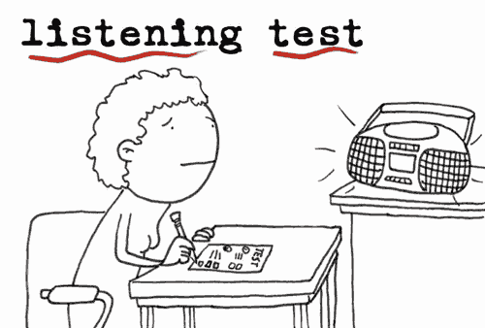



**✪ In the listening test, each part has a different theme or focus. ✪**

**Section 1: General Conversation**

💣 In section 1, you will hear a conversation between two people and it is almost always someone making an appointment or making a booking of some kind

An interview about student wellbeing;

**Example**

A telephone conversation about buying travel tickets;

A student asking about accommodation.

Making hotel reservation

**Question Types**

Gap-filling questions, form / table / sentence completion

**Section 2: A Talk / A Speech**

💣 In section 2, you will hear someone talking by themselves about a non-academic subject

**Example**

A radio programme about local history;

A short talk about healthy eating;

A presentation about student services.

**Question Types**

Multiple choices, gap-filling questions



**Section 3: Academic Conversation**

💣 Section 3 switches to an academic context

An academic conversation in a specific field

A discussion between a student and a tutor about an

**Example**

assignment

A seminar discussion about a research project

Two students discussing homework.

**Question Types**

Multiple choices, gap-filling questions, sentence completion

**Section 4: Academic Lecture**

💣 Section 4 is normally an academic lecture and you will hear one person (normally the lecturer or professor) talking for an extended period of time.

A lecture on the history of photography

**Example**

A lecture on volcanoes

A lecture on animal behaviour

**Question Types**

Short answers, matching, tabe / sentence completion

**✪ Listening Band Score Scale ✪**

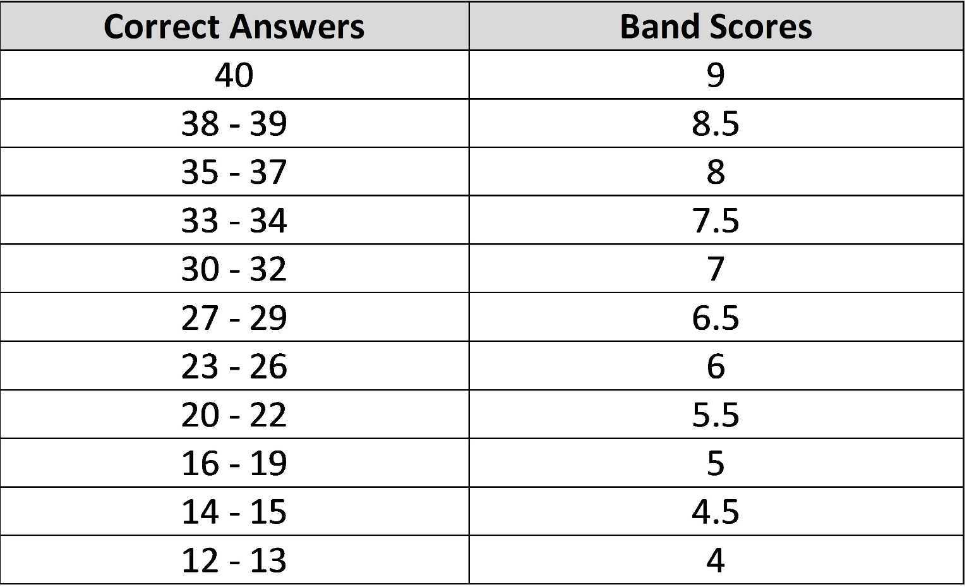

**✪ Reminders for IELTS Listening Test ✪**

➊ don’t worry about what you write on the exam sheet

➋ transfer your answers to the answer sheet carefully

➌ look out fo**r paraphrased words**

➍ **no spelling mistakes 🞺🞺**

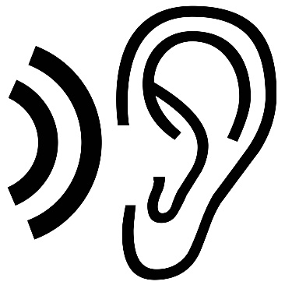➎ capitalization of proper nouns

➏ **grammar mistakes** penalized

➐ write all answer on answer sheet provided

➑ get used to listening to speeches and lectures if possible **(Ted Talk)**

**[2] Before While After**

**🕮 Before you listen:**

🡺 Think about the topic of the text you are going to listen to.

|  |
| --- |
| 💣 What do you already know about it?  💣 What could possibly be the content of the text?  💣 Who is (are) the speaker (s) in the content?  💣 Which words come to mind that you already know?  💣 Which words would you want to pay special attention to? |

🡺 Check whether you have understood the task and instructions correctly.

|  |
| --- |
| 💣 What is the word limit?  💣 Do I have to write numbers or letters?  💣 What is the theme of the recording? |

🡺 Think about what type of text you are going to listen to.

🡺 Relax and make yourself ready to pay attention to the listening text

🡺 Use this time to work out the topic, and decide what sort of information and answers you need to listen for



🡺 Use a pencil to underline key words in the questions.

**🕮 While you listen:**

🡺 You do not have to understand every single word. Try to ignore those words that you think are less important anyway.

|  |
| --- |
| 💣 If there are words or issues that you don't understand, use your general knowledge as well as the context to find out the meaning. |

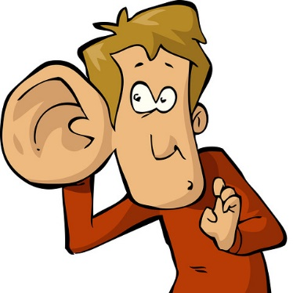

🡺 Focus on key words and facts.

🡺 Take notes to support your memory.

🡺 Intonation and stress of the speakers can help you to understand what you hear.

|  |
| --- |
| 💣 What might happen next?  💣 What might the speakers say?  💣 Which words might they use?  💣 What does the speaker imply by what he/she says? |

🡺 If you cannot answer a question, move on to the next one.

**🕮 After you listen:**



🡺 Review your notes (what you have written down) if you haven’t decide which item is the answer

🡺 Check whether you have completed your task correctly.

🡺 Transfer your answer onto the answer sheet carefully.

|  |
| --- |
| 💣 You have ten minutes to do this, but you need to get going on this straightaway.  💣 If you put your answers in the wrong place on the answer sheet, you will lose marks. |

🡺 Go back to any questions you could not answer and try to guess the answer from the context.

(Section 1 & 2 🡺 usually easier)

**[3] 🞺 IELTS Task Practice (Section 2) (L9)**

**SECTION 2 Questions 11 – 20**

**Questions 11 – 16**

Complete the notes below.

Write **NO MORE THAN THREE WORDS AND/OR A NUMBER** for each answer.

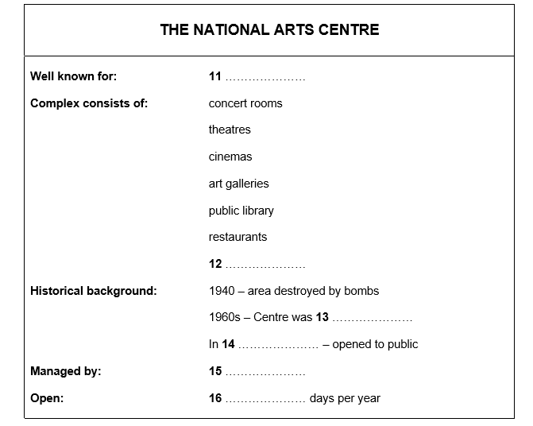

**Questions 17 – 20**

Complete the table below.

Write **NO MORE THAN THREE WORDS AND/OR A NUMBER** for each answer.

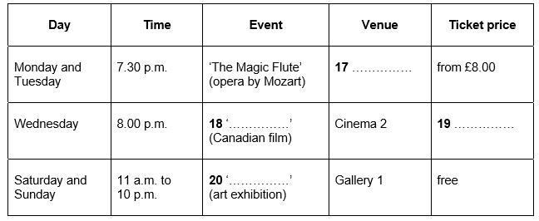

|  |
| --- |
|  |

**[4] 🞺 IELTS Task Practice - Matching (Warm-up) (T9)**

You will hear a Communication Studies student talking to his tutor about optional courses for the next semester.

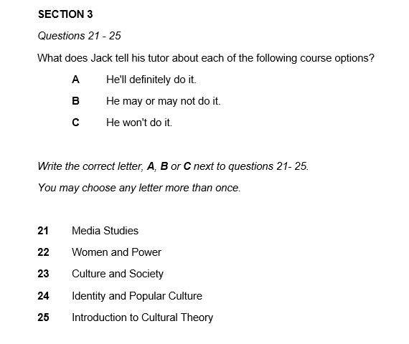

**Your score: _________**

**🖭🖭 Recording Script 🖭🖭:**

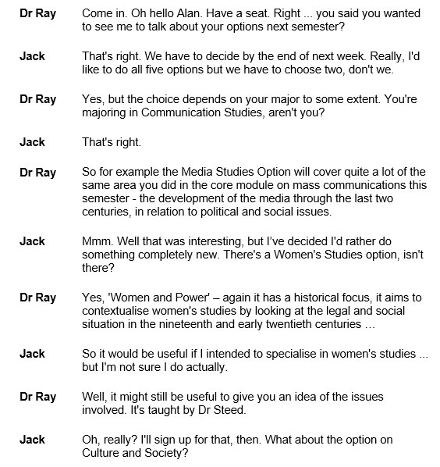

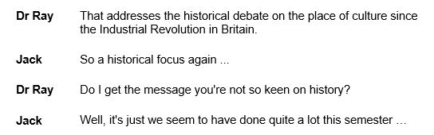

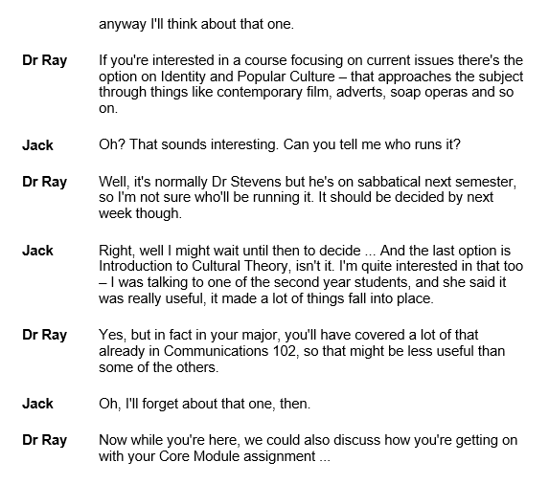

**[5] 🞺 IELTS Sample Task Practice (Section 3) (L10)**

**SECTION 3 Questions 21 – 30**

**Questions 21 and 22**

Complete the notes below.

Write **NO MORE THAN THREE WORDS AND/OR A NUMBER** for each answer.

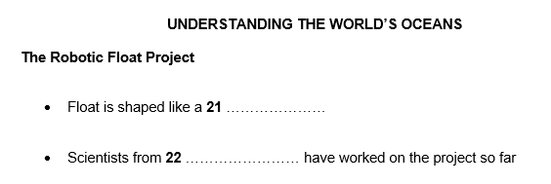

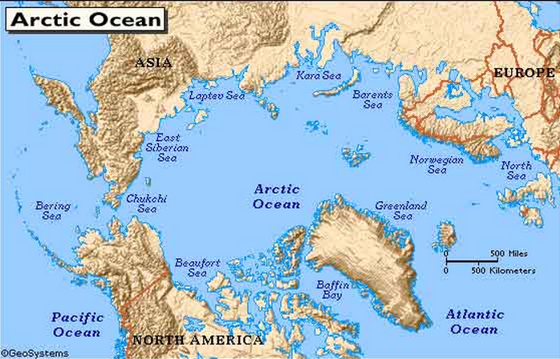

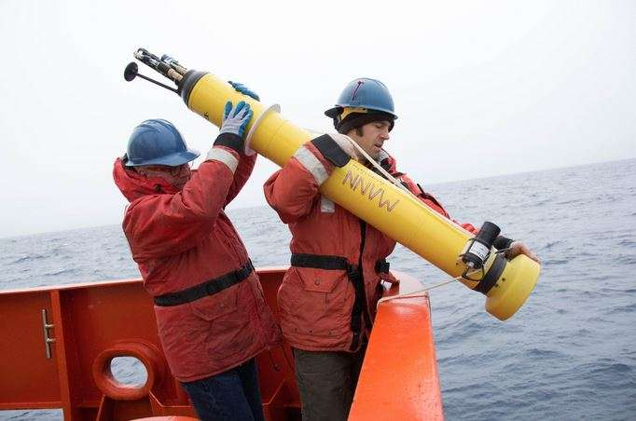

**Questions 23 – 25**

Complete the notes on the diagram below.

Write **NO MORE THAN THREE WORDS AND/OR A NUMBER** for each answer.

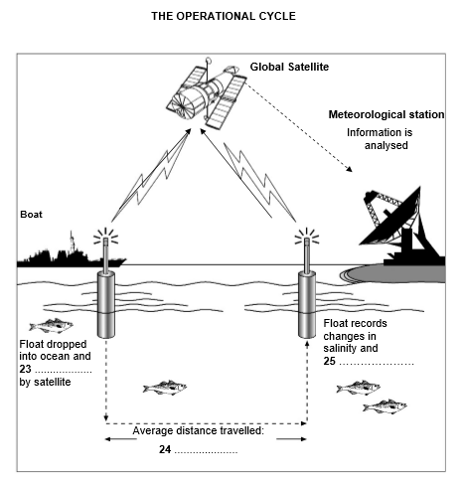

**Questions 26 – 30**

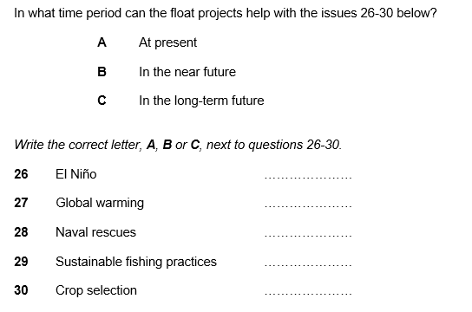

|  |
| --- |
|  |

**[6] 🞺 IELTS Task Practice – Short Answers (Warm-up) (T10)**

**Questions 11 – 16**

Write **NO MORE THAN THREE WORDS AND/OR A NUMBER** for each answer.

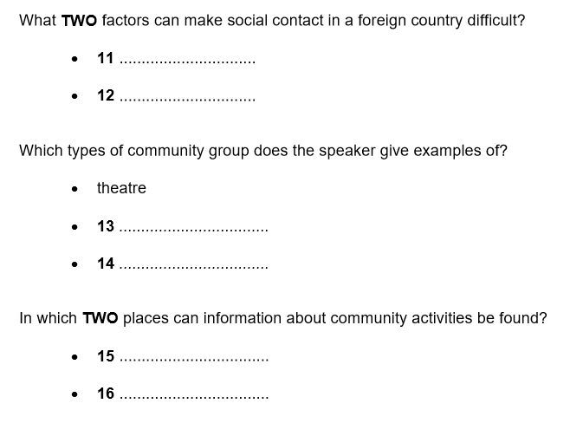

**🖭🖭 Recording Script 🖭🖭:**

You will hear an extract from a talk given to a group who are going to stay in the UK.

Good evening, and welcome to the British Council. My name is John Parker and I’ve been asked to talk to you briefly **about certain aspects of life** in the UK before you actually go there. **So** I'm going to talk **first** about the best ways of making social contacts there. **Now** you might be wondering why it should be necessary. After all, we meet people all the time. **But** when you’re living in a foreign country it can be more difficult, **not just because of** the language, **but because** customs may be different.

If you’re going to work in the UK you will probably be living in **private accommodation**, so it won’t be quite so easy to meet people. **But** there are still things that you can do to help yourself. **First of all,** you can get involved in activities in your local community, join a group of some kind. **For example,** you’ll probably find that there are theatre groups who might be looking for actors, set designers and so on, **or if** you play an instrument you could join music groups in your area. **Or if** you like the idea of finding out about local history there’ll be a group for that too. **These are just examples**. And the best places to get information about things like this are either the town hall or the public library. Libraries in the UK perform quite a broad range of functions nowadays – they’re not just confined to lending books, although that’s their main role of course.

**[7] Common Spelling Mistakes in IELTS Listening**

|  |
| --- |
| **✪ Single and double consonants** |
| mouth🕮 Spelling mistakes are common when single or double consonants occur nearby in a word.  💣 A single consonant is followed by a double consonant: 🡺 A**c**ro**ss**, Pro**c**e**ss**, Ha**r**a**ss**, Di**s**a**pp**oint, Re**c**o**mm**end, To**m**o**rr**ow, Pro**f**e**ss**or, Ne**c**e**ss**ary  💣 A double consonant is followed by a single consonant: 🡺 Para**ll**e**l**, A**pp**a**r**ent, Exa**gg**e**r**ate, O**cc**a**s**ion, O**cc**u**r** (but O**cc**u**rr**ed), Co**mm**i**t** (but Co**mm**i**tt**ed)  💣 Some common words with two pairs of consonants: 🡺 Su**cc**e**ss**, Po**ss**e**ss**, A**cc**e**ss**, A**ss**e**ss**, A**dd**re**ss**, A**cc**o**mm**odation, Emba**rr**a**ss**, Mi**ll**e**nn**ium |

|  |
| --- |
| **✪ Weak vowel sounds** |
| mouth🕮 Some words are difficult to spell because they contain the **schwa** or **[ə]**, a weak vowel sound.  💣 Examples of words containing more than one schwa include: 🡺 sep**a**r**a**te (adj.), def**i**n**i**te, desp**e**r**a**te, temp**e**r**a**ture, lit**e**r**a**ture, gen**e**r**a**l, rel**e**v**a**nt, cat**e**g**o**ry  speaking💣 Other problematic schwa words include: 🡺 d**e**scribe, d**e**cline, d**e**spite; ✪ but d**i**spute, d**i**screte, d**i**splay 🡺 cap**a**ble, achiev**a**ble, understand**a**ble; ✪ but poss**i**ble, vis**i**ble, access**i**ble 🡺 perform**a**nce, attend**a**nce, ignor**a**nce; ✪ but independ**e**nce, sent**e**nce, exist**e**nce  💣 Sometimes the schwa sound conceals a barely-pronounced [**r**]: 🡺 opp**or**tunity, p**ur**sue, p**er**suade, s**ur**prise |

|  |
| --- |
| **✪ Changes of spelling when words change form** |
| mouth🕮 A consonant can change when a noun becomes an adjective: 🡺 benefi**t** > benefi**c**ial; influen**c**e > influen**t**ial;  circumstan**c**e > circumstan**t**ial  🕮 A vowel can change or be lost when a verb becomes a noun: 🡺 maint**ai**n > maint**e**nance; pron**ou**nce > pron**u**nciation, arg**ue**> arg**u**ment  🕮 A vowel may double when a noun becomes a verb: 🡺 succ**e**ss > succ**ee**d; exc**e**ss > exc**ee**d; proc**e**ss > proc**ee**d  🕮 A final consonant is often doubled when a verb changes form: 🡺 occu**r** > occu**rr**ed; refe**r** > refe**rr**ed; begi**n** > begi**nn**ing |

|  |
| --- |
| **✪ Pairs of frequently confused spellings in IELTS** |
| **💣 till** ≠ **until** (not *untill) **💣 lose** ≠ **loose** (one is a verb; the other is an adjective) **💣 affect** ≠ **effect** (one is a common verb; the other is its noun form) **💣 forth** ≠ **fourth** (one means ‘forward’; the other means ‘number four’) **💣 fourth** but **forty** (not *fourty) **💣 high** but **height** (not *hight) **💣 great** but **grateful** (not *greatful) **💣 precede** ≠ **proceed** (one means ‘go before’; the other means ‘go ahead’) **💣 principle** ≠ **principal** (one means ‘truth’; the other means ‘main’) **💣 site** ≠ **sight** (one is a place; the other is something to see, as in sightseeing not *siteseeing) **💣 copywriter** ≠ **copyright** (one writes advertising; the other means ‘intellectual property’) |

**Common difficult words which appear in IELTS Listening**

|  |  |  |  |  |
| --- | --- | --- | --- | --- |
| amateur | entrepreneur | hierarchy | liaison | medieval |
| miscellaneous | queue | questionnaire | rhythm | vacuum |
| assessment | accommodation | commencement | intermediate | Registrar’s office |
| catalogue | strategies | food pyramid | blackcurrant | treatment |
| remedy | anthropology | archaeology | humanities | agriculture |
| dormitory | avenue | bungalow | terraced house | suburb |
| technical cooperation | satisfactory | aquarium | suite | mandatory |
| compulsory | tranquil | scuba-diving | embroidery | treadmill |
| humid | city council | decade | century | guarantee |
| pedestrian | prototype | encyclopedia | satellite | inhabitant |

**[8] 🖊 IELTS Listening Test Practice 1 (T9+T10)**

**Section 1 Question 1-10** (0.00-6.22)

**Questions 1-5**

Complete the notes below.

**Write NO MORE THAN TWO WORDS AND/OR A NUMBER for each answer.**

**CHINDREN’S ART AND CRAFT WORKSHOPS**

|  |
| --- |
| *Example Answer*  Workshop organized every: **Saturday** |

* Adults must accompany children under 1._____________________
* Cost: £ 2.50
* Workshops held in: Winter House, 2.____________________ Street
* Security device: must push the 3.__________________ to open the door.
* Should leave car behind the 4.____________________
* Book workshops by phoning the 5.______________________ (on 200765)

**Questions 6-10**

Write NO MORE THAN TWO WORDS for each answer.

**Next two workshops**

|  |  |  |  |
| --- | --- | --- | --- |
| **Date** | **Workshop title** | **Children advised to wear** | **Please bring**  **(if possible)** |
| 16/11 | ‘Building 6.______________________ | 7.___________________ | 8.___________________ |
| 23/11 | 9.______________________ | (nothing special) | 10.__________________ |

**Section 2 Question 11-20**  (6.23-11.11)

**Questions 11-14**

Complete the sentences below.

**Write NO MORE THAN TWO WORDS AND/OR A NUMBER for each answer.**

**TRAIN INFORMATION**

11. Local services depart from _______________________ railway station.

12. National services depart from the _____________________ railway station.

13. Trains for London depart every ____________________ each day during the week.

14. The price for a first class ticket includes ______________________.

**Questions 15-17**

Complete the table below.

Write **NO MORE THAN TWO WORDS AND/OR A NUMBER** for each answer.

|  |  |
| --- | --- |
| **Type of ticket** | **Details** |
| Standard open | No restrictions |
| Supersave | Travel after 8.45 |
| Special | Travel after 15.____________________ and at weekends |
| 16._______________________ | Buy at least six days ahead  Limited numbers  17.______________________ essential |

**Questions 18-20**

Choose THREE letters, A-G

Which THREE attractions can you visit at present by train from Trebirch?

A a science museum

B a theme park

C a climbing wall

D a mining museum

E an aquarium

F a castle

G a zoo

**Section 3 Question 21-30** (11.48-18.19)

Complete the tables below.

Write **NO MORE THAN THREE WORDS AND/OR A NUMBER** for each answer.

**Dissertation Tutorial Record (Education)**

Name: Sandy Gibbons

|  |  |  |
| --- | --- | --- |
| **Targets previously agreed** | **Work completed** | **Future action suggested** |
| Investigate suitable data analysis software | - Read IT 21._________________________  - Spoken to Jane Prince,  Head of the 22._________________________ | Sign up for some software practice sessions |
| Prepare a 23._________________________  For survey | - Completed and sent for review | Add questions in section three on 24._______________________ |
| Further reading about discipline | - Read Banerjee  - N.B. couldn’t find Ericsson’s essays on managing the 25._________________________ | Obtain from library through special loan service |

|  |  |  |
| --- | --- | --- |
| **New targets** | **Specific suggestions** | **Timing** |
| Do further work on  Chapter 1  (Given the title:  *Context* 26.______________________) | - Add statistics on the  27.________________________  in various zones  - Include more references to works dated after 28.________________________ | By the 29.________________________ |
| Prepare list for main sections for Chapter 2 | - Use index cards to help in organization | Before starting the  30._________________________ |

**Section 4 Question 31-40** (18.54-end)

**Questions 31-37**

Choose the correct letter, A, B or C.

**The History of Moving Pictures**

31. Some photographs of a horse running showed

A. all feet off the ground.

B. at least one foot on the ground.

C. two feet off the ground.

32. The Scotsman employed by Edison

A. designed a system to use the technology Edison had invented.

B. used available technology to make a new system.

C. was already an expert in motion picture technology.

33. One major problem with the first system was that

A. only one person could be filmed.

 B. people could only see very short films.

C. the camera was very heavy.

34. Rival systems started to appear in Europe after people had

A. been told about the American system.

B. seen the American system.

C. used the American system.

35. In 1895, a famous new system was developed by

A. a French team working alone

B. a French and German team working together

C. a German team who invented the word ‘cinema’

36. Longer films were not made at the time because of problems involving

A. the subject matter

B. the camera

C. the film projector



37. The ‘Lantham Loop’ invention relied on

A. removing tension between the film reels

B. adding three more films reels to the system

C. making one of the film reels more effective

**Questions 38-40**

Complete the sentences below.

Write **NO MORE THAN THREE WORDS** for each answer.

38. The first motion picture was called ‘The __________________________.’

39. ________________________ were used for the first time on film in 1926.

40. Subtitles were added to *The Lights of New York* because of its ____________________.

